**PRAKASH SARAVANAN**

**9655694902**

E-mail Id: [prakashsaravanan3017@gmail.com](mailto:prakashsaravanan3017@gmail.com)

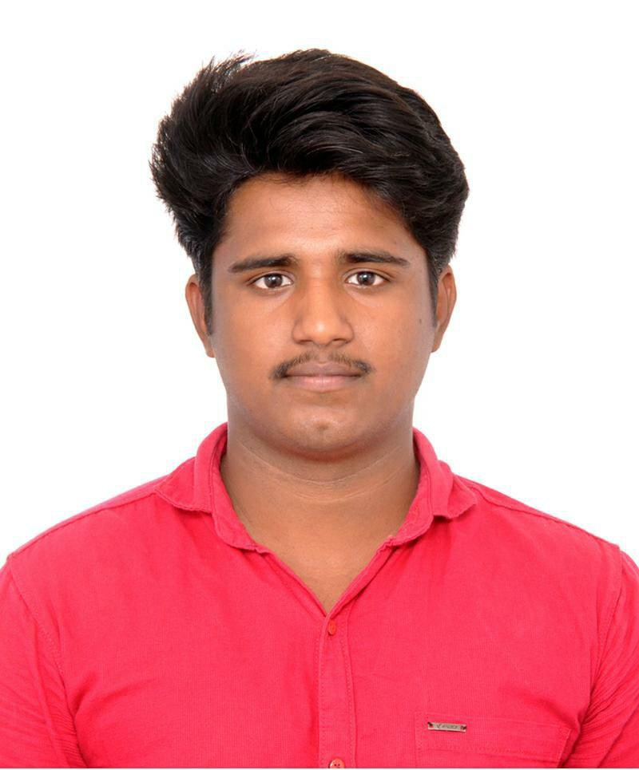

LinkedIn ID: <https://www.linkedin.com/in/brazil-usva-6178b91b1>



**CAREER OBJECTIVE:**

Seeking for an opportunity in a reputed organization which will help me deliver and upgrade my skills in organization level and meet the demands of the organization.

**ACADEMIC QUALIFICATION:**

|  |  |  |  |  |  |
| --- | --- | --- | --- | --- | --- |
| **S.NO** | **COURSE** | **INSTITUTION** | **BOARD/**  **UNIVERSITY** | **PERCENTAGE/ CGPA** | **Year of passing** |
| 1 | B.E Electrical and Electronic  Engineering | Karpagam Academy of Higher Education | Deemed  University | 7.5 | 2025 |
| 2 | H.S.C | sri vijay vidyalaya matric higher secondary school, dharmapuri | STATE | 60.8 | 2020 |
| 3 | S.S.L.C | sri vijay vidyalaya matric higher secondary school, dharmapuri | STATE | 83 | 2018 |

**TECHNICAL SKILLS:**

✔ MSOffice (Word, Excel, Power Point)

✔ PLC

✔Advance C Programing

**STRENGTH:**

✔ Extrovert

✔ Adaptable

✔ Punctual

✔ Problem Solvinng

**CERTIFICATE:**

Certified in ‘Mobile Phone Service Hands On’ From New Technology Institutions in 17th Jun 2023.

Certified in ‘Programmable Logic Controller’ From Karpagam

Academy of Higher Education in 24th August 2023.

**LANGUAGES KNOWN:**

✔ English

✔ Tamil

**PERSONAL DETAILS:**

Father’s Name: SARAVANAN Date of Birth: 21/ 07/ 2002

Address: 4/51, Kumbalapadi , Indur (Pt), Dharmapuri (Dt), Tamilnadu

**DECLARATION:**

I hereby declare that all above mentioned information is in accordance with factor truth up my knowledge and I bear the responsibilities for the correctness of the above mentioned particulars.

[PRAKASH SARAVAN]